**Measurement of IL6 Colocalization with Insulin and Glucose**

Step-by-Step Protocol

**Goals**: 1) Familiarize yourself with working with fluorescence data, including the pixel classifier; 2) Understand how QuPath can interface with ImageJ, and run ImageJ macros directly for more advanced calculations.

Assumes you have gone through the collagen pixel classifier tutorial already. This workflow is more streamlined than the one presented in the March 2019 workshop.

1. Create a new project in QuPath 0.2.0 (any milestone)
2. Add the file Pancreas_Insulin488_Glucagon555_Il6R647.czi to the project
   1. Make sure the Image Type is “fluorescence”
   2. These are cropped images of human pancreas sections. Green = insulin; Blue = glucagon; Red = IL6R (cytokine receptor). The insulin and glucagon define the islets.
3. Drag the 2 associated files (IsletMeasurement.groovy and IsletIntersection.ijm) into the project folder.
4. Create a class for the islets. It can be named anything.
5. Train a pixel classifier to recognize islets vs. pancreas tissue. Use the Ignore class for all of the tissue outside of the islets. Try to be as accurate as possible, especially about the edges of the islets. Try different features to find ways to improve the classification.
6. When you are satisfied with the pixel classifier, click “Create Objects”. The objects should be annotation objects, split, with a minimum size of 500 um (or whatever you feel is appropriate for an islet). The minimum size threshold helps remove the small areas of only a few cells that are green but are not islets.   
   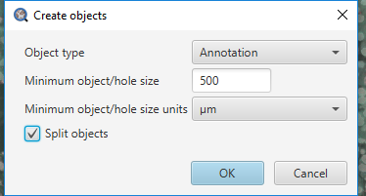
7. In some of the islets, you may notice holes in the middle, where there were cells that were both insulin-negative and glucagon-negative.   
   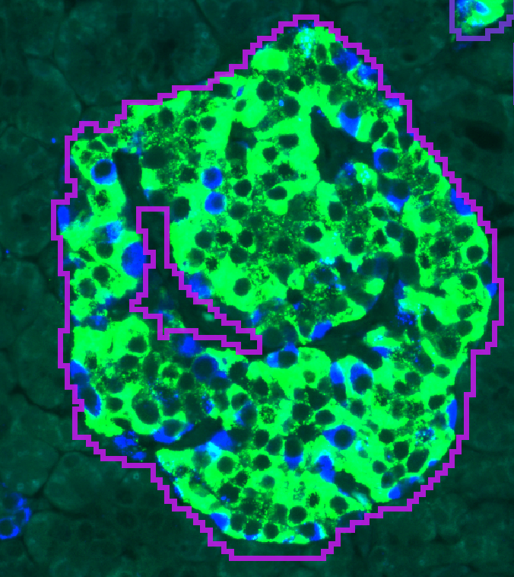  
     
   To fix these, select all of your annotations in the Annotation tab, then go to Objects > Annotations > Fill holes  
   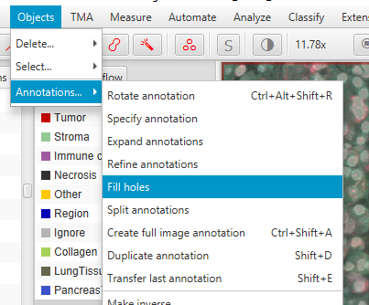 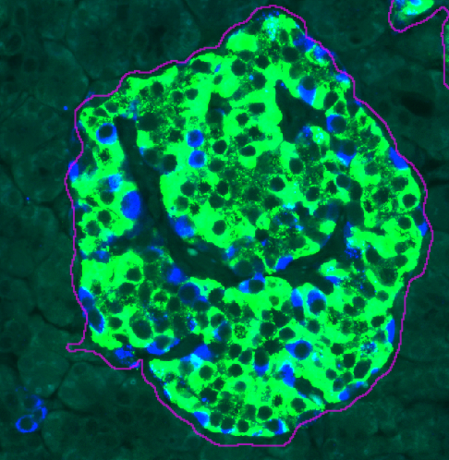
8. Now that we have the islets annotated, we would like to perform some complex measurements on them. Specifically, we want to see if IL6R is predominantly produced by the beta cells (insulin producing) or the alpha cells (glucagon producing). While there is not a straightforward way to perform this analysis directly through QuPath, we can easily write an ImageJ macro that can.
   1. Open IsletIntersection.ijm in ImageJ and read through it.
   2. For each islet, this macro finds the glucagon+, insulin+, and IL6R+ regions. Then, it calculates which areas are both glucagon+ IL6R+, and which are insulin+ IL6R+. It sends all of these regions back to QuPath. Note: the intensity thresholds to determine what is positive for the 3 channels were set manually. You may want to adjust these.
9. The script IsletMeasurements.groovy processes each islet one at a time, sending the data to ImageJ for the macro, and then using the returned ROIs to calculate colocalization fractions. Read through this script, and then run it. As long as the .ijm file is in the project folder, it will automatically find it and run the ImageJ macro for each islet. It will count each islet as it processes and the message area will say “done” once it is finished.
10. There will be now 2 new measurements for each islet: Insulin IL6 overlap and Glucagon IL6 overlap. Click on the measurements table icon, and select “Show annotation measurements”.  
    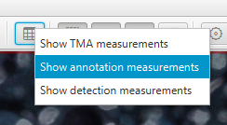
11. You can export all of the annotation measurements to a table to process them further in Excel/Prism by clicking “Save”. Or, you can view a histogram of colocalization across all islets by clicking “Show histograms” (bottom left corner) and then selecting the measurement of interest.
12. This is a rather specific example application, but the general concepts that are shown are broadly useful. You can use any ImageJ macro or pre-written plug-in on your data, as long as it only needs to process a small area at a time. QuPath seamlessly handles sending data and objects back and forth between itself and ImageJ in an efficient manner.